**System Setup**

This guide outlines the steps necessary for setting up a system for development with the “Collect & Characterize RF Signals of Interest Using Software Defined Radio (SDR)” project. As originally designed, the requirements for this project are a Linux system, gr-scan, and MATLAB. While Arch Linux was used previously, Ubuntu is easier to setup and maintain. The following sections will detail the installation of Ubuntu, setup for git and gr scan, and MATLAB.

**Install Ubuntu 16 or later**

Download: [ubuntu-16.04.4-desktop-amd64.iso](http://releases.ubuntu.com/16.04.4/ubuntu-16.04.4-desktop-amd64.iso?_ga=2.143821628.826732460.1524670265-1820524483.1524506261)

A virtual machine (VM) was used to perform the following installation and it is recommended that first time users use a VM as well to get familiar with the process. However, using a VM can seriously impact performance. A separate, dedicated drive should be used for the final system.

1. Boot into the installation media and click “Install Ubuntu” to begin.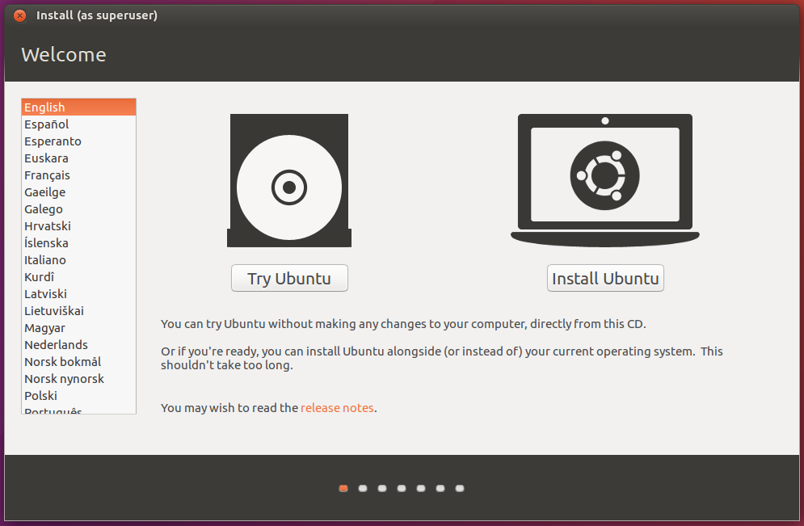
2. Check the boxes for downloading updates and installing third-party software.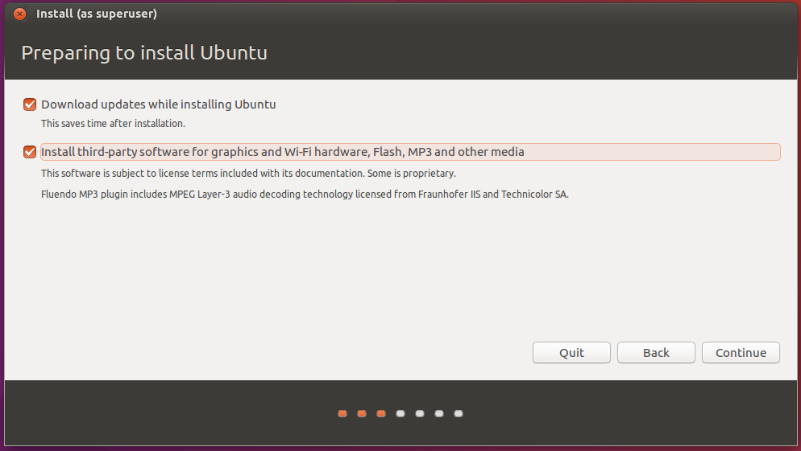
3. Select “Erase disk…” and click install now. The following installation was done on a virtual machine with only one drive. Use caution if more drives are present.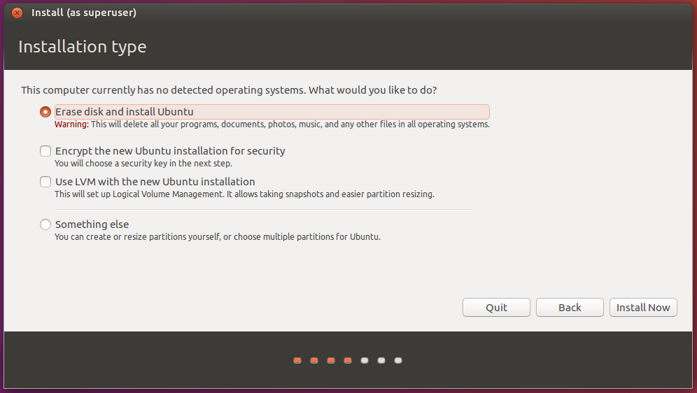
4. Double check the drive name below is the correct drive for installation and click Continue. 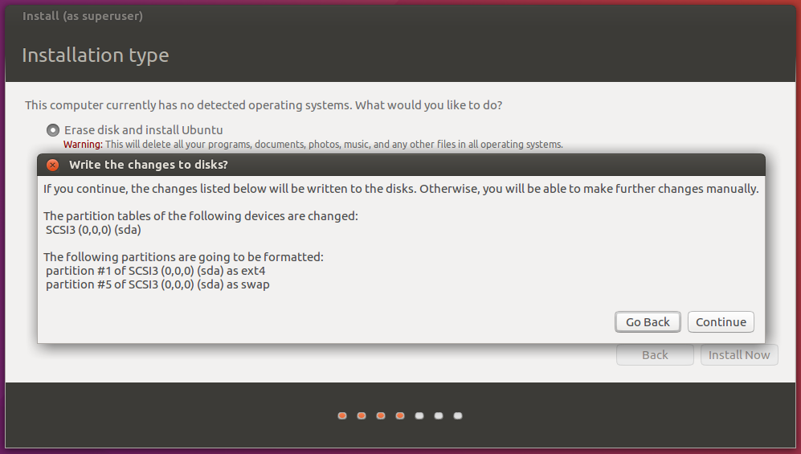
   1. Drive names can be checked in the terminal by running the following command:
      1. $ sudo fdisk -l
5. Select your appropriate time-zone.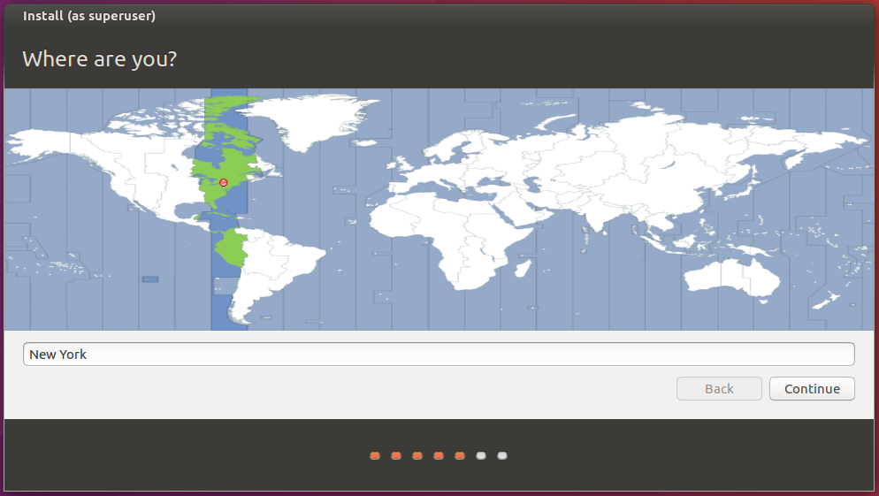
6. Select your keyboard layout.

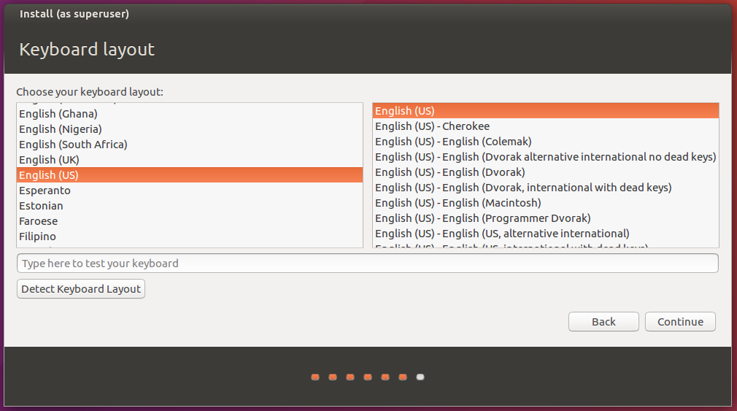

1. Choose a username and password. 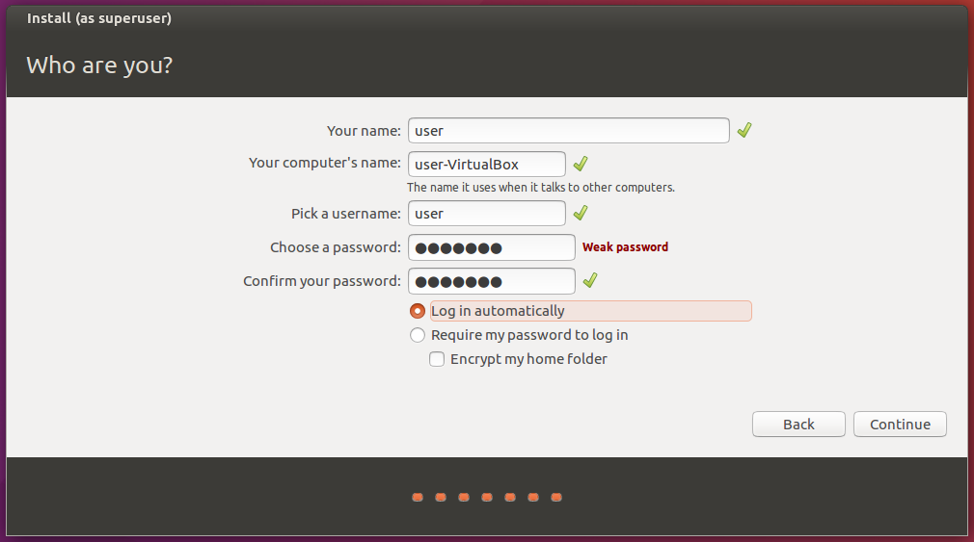
2. Wait.

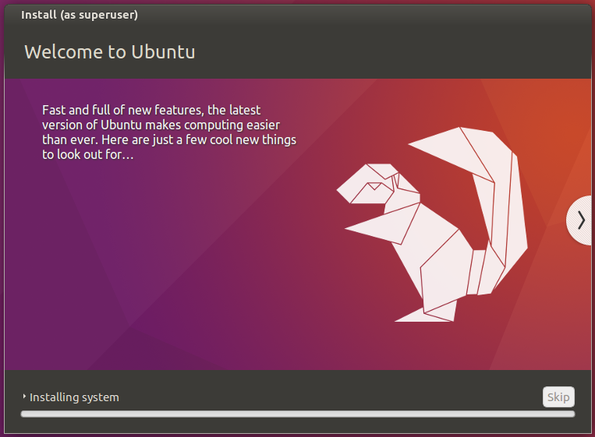

1. Once the installation is complete, reboot and remove the installation media.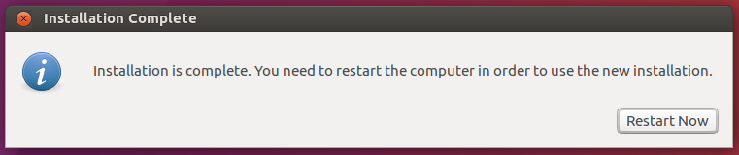
2. The following will be displayed at first login. It is listed here for reference.

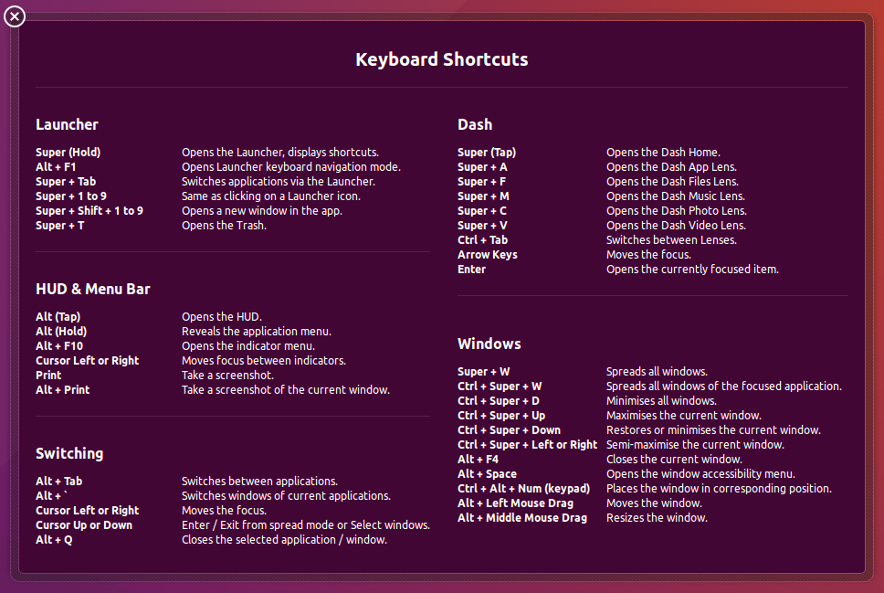

1. Right-click the desktop and open a terminal.

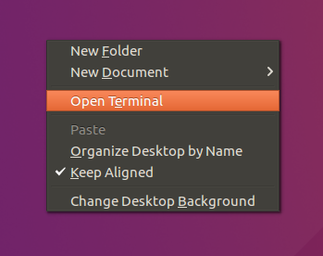

1. Make sure everything is up to date
   1. $ sudo apt-get update
      1. Sudo runs a process with root privileges. Installing packages or changing system settings will require this command.

**Prerequisite files and gr-scan**

The user must have created a github account and be added as a contributor to the git repository (repo) for gr-scan. See the github guide included with this guide for reference on github commands.

1. Install pre-requisite packages
   1. $ sudo apt-get install git gnuradio gr-osmosdr libboost-all-dev
2. Create a directory for gr-scan, download the latest files from github, and compile gr-scan with the following commands:
   1. $ mkdir gr-scan
      1. This will create a directory in the user’s home directory (~ or /home/<username>).
   2. $ cd gr-scan
      1. Change directory to the created to the new gr-scan directory
   3. $ git init
      1. Initialize the directory as a local git repository
   4. $ git config --global user.name “your name”  
      $ git config --global user.email your@email.com
      1. Set user’s name and email for their github account
      2. This only needs to be done once per system.
   5. $ git remote add origin [https://github.com/user/<repository](https://github.com/user/%3crepository)>
      1. Add the remote repo, named conventionally as origin, to the configuration for the local repo.
   6. $ git pull origin <branch name>
      1. The branch name will usually be master but can be different depending on what branches are created and used.
   7. $ make
      1. Uses the Makefile to compile a gr-scan executable.
      2. Compiler should give no warnings or errors.
   8. Output of all commands above.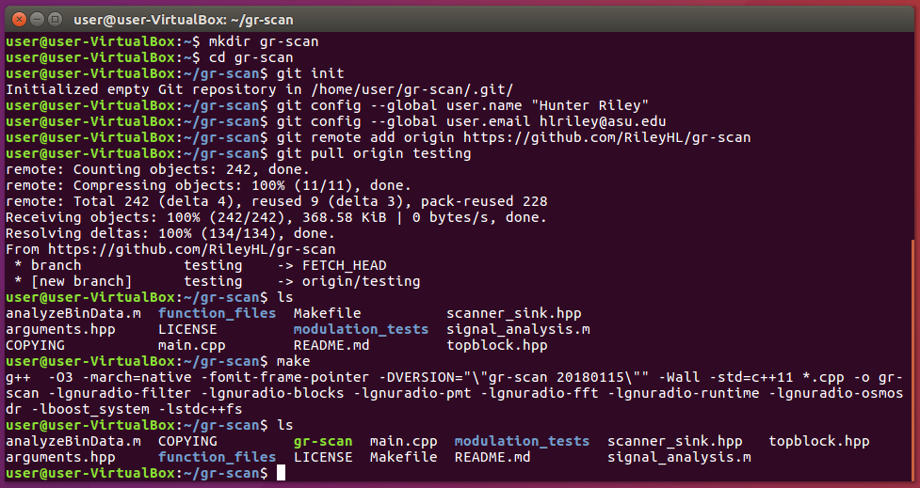

**Setting up MATLAB**

Download: [MathWorks Login](https://www.mathworks.com/login)

Sign into MathWorks and download MATLAB r2018a or newer for Linux (64-bit.)

1. The zip archive will be in ~/Downloads. Create a working directory and install MATLAB with the following commands:
   1. $ cd ~/Downloads
      1. Change directory to Downloads.
   2. $ mkdir matlab && mv matlab*zip matlab/
      1. Make a directory called matlab and move the downloaded zip file to it.
   3. $ cd matlab
      1. Change directory to matlab.
   4. $ unzip *
      1. There should only be one zip file so using the wild card instead of the long filename works.
   5. $ sudo ./install
      1. Run the installer with root privileges.
   6. Output from the above commands.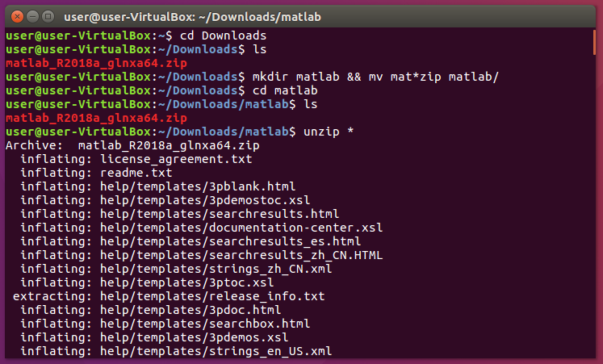

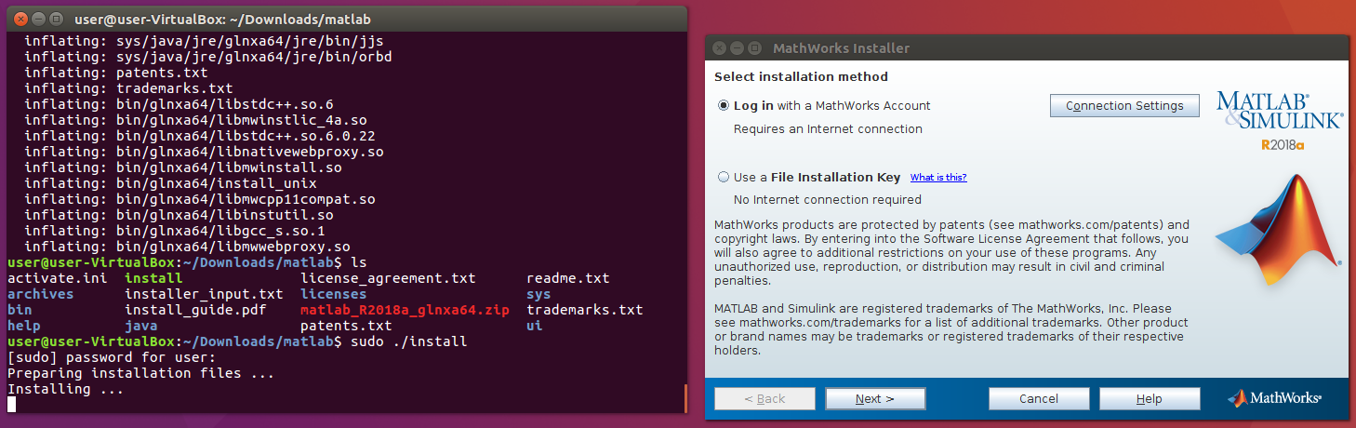

1. Click next and accept the license agreement.
2. If MATLAB says you must verify your university login, a link with the text “click here” will be given in the pop-up, but it will not work. To get the link, right click the message box and click “Select All.” Right click again and click “copy.” Open a new document using LibreOffice Writer. Paste what you copied into the document, the “Click here” link will be recognized as a link. Ctrl+click the link and Firefox will open the ASU login page. Login and the installation can continue.
3. Click next to accept all default paths and packages until you get to the “Select desired installation options” screen. Check the “Create symbolic links tto MATLAB scripts in:” box. 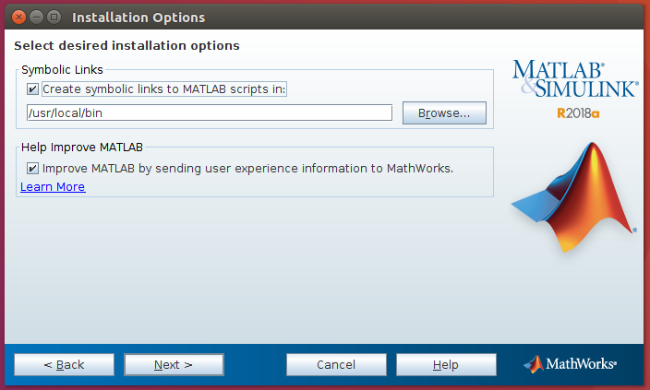
4. Click keep clicking next and confirm installation. Wait.
5. Enter the system user’s name.

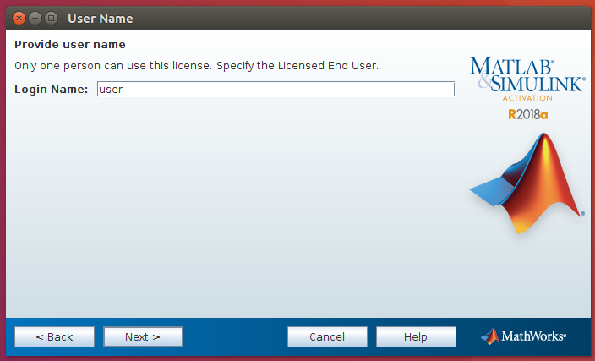

1. Click next to complete the activation.
2. Start MATLAB
   1. Ubuntu
      1. $ matlab -softwareopengl
      2. If the -softwareopengl run option isn’t used, the dialog for entering gr-scan run options will have no text.
   2. Arch (Different distribution)
      1. $ LD_PRELOAD=”/usr/lib/libstdc++.so.6” matlab
      2. Arch had an issue where MATLAB couldn’t find the appropriate library when calling gr-scan. This more than likely will not happen in Ubuntu, but the solution is listed here just in case. Double check the path to libstdc++.so.6 if it cannot be found.
   3. If MATLAB gives you a warning about your time zone not being accurate, exit MATLAB then exit MATLAB and create the following environment variable:
      1. $ export TZ=America/<city>
      2. This variable will only exist for the current terminal and session
      3. Restart MATLAB from the same terminal.